**Authors:**

Kidany Berrios 801-09-0603

Kevin Castillo 801-09-1107

**TAPtoBUY ER Diagram Report:**

**Entity sets:**

1. **item:** Represents an item put on sale or on auction by a given seller (it is the generalization of these two). It contains the title, duration, and the shipping price given by the seller. It also tells whether the item duration time has ended or not.
2. **item_info:** Describes the item itself (not the sale or auction). It includes item attributes such as the model, brand, dimensions, description, an image, and what product it is for example an iPhone 3g.
3. **category:** Holds all the categories available; categories, subcategories, the subcategories of these subcategories and so on.
4. **item_for_sale:** The specialization of an item that represents an item put on sale by a seller. It contains the item’s instant price, the starting quantity provided by the seller and the remaining quantity of them.
5. **item_for_auction:** The specialization of an item that represents an item that is for auction. It contains the starting bid price provided by the seller, the current bid price and amount of bids placed by users, and the rate at which bid prices increment.
6. **cart:** Every user has one cart which has an unique id and the number of items that the user has put on it.
7. **bid:** Represents a bid placed by a given user to an item in auction. This bid is related to one user and to one item for auction. It contains the amount of money that the user placed, when he/she placed the bid and if this bid is the one currently winning.
8. **user:** Represents an user account with its unique id, its username, password, first_name, last_name, and email address. It is related to the shipping addresses, credit cards and billing addresses of the user.
9. **credit_card:** Represents the credit cards associated to a user and to the orders they hava bought or sold. It contains attributes such as: card number, holders name and expiration date.
10. **billing_address**: The billing address associated to a credit card. It contains attributes such as country, contact name, street, city, state, zip code, and telephone number.
11. **shipping_address:** The shipping address where items are going to be sent. It contains the same attributes of billing address.
12. **item_order:** Describes an order of an item in sale that has been bought by a user. It contains the order id, the date when the order took place.
13. **auction_order:** Describes an order of an item on auction that has been won. It contains the order id and the date when the order took place.
14. **admin:** Administrator user account which has the same attributes of a regular user but can manage categories, get report of orders and edit user accounts.

**Relationship sets:**

1. **item_has_info:** States that every item is related to one item_info and that every item_info is related to only one item.
2. **item_from_cat**: States that many items can be related to one category and that every item is within a category.
3. **has_subcat:** Allows getting all the categories in the database by relating all subcategories to their parent categories.
4. **puts_on_sale**: states that one user can put many items on sale and every item on sale is from only one user.
5. **puts_on_auction:** states that one user can put many items for auction and that every item on auction is from only one user.
6. **places_bid:** states that a user can put many bids and that every bid comes from only one user.
7. **bid_for_item:** states that there can be many bids placed for a single item and that every bid is for an item.
8. **ranks:** says that a buyer can rank many sellers and has the attribute of the amount of stars given by a user to another.
9. **user_crdt_card:** states that every user has one or more credit cards and that every credit card must belong to one user.
10. **user_ship_addr:** states that every user has one or more shipping addresses and that each shipping address belongs to one user.
11. **crcard_bill_addr:** specifies that every credit card has a billing address associated to it and that every billing address is related to one credit card.
12. **auc_ord_shaddr:** tells that every auction order is related to one shipping address and that one shipping address can be related to many auction orders.
13. **auc_ord_crcard:** tells that every auction order is related to one credit card and that one credit card can be related to many auction orders.
14. **won_auc_ord:** states that every auction order is for one item_for_auction. Also specifies the price paid for the item.
15. **itm_ord_shaddr**: specifies that every item order is related to one shipping address and that one shipping addess can be related to many item orders.
16. **itm_ord_crcard:** tells that every item order is related to one credit card and that one credit card can be related to many item orders.
17. **buyr_bght_ordr:** tells that every bought item order belongs to one buyer and that a buyer may have several bought item orders.
18. **sellr_bght_ordr:** tells that every bought item order belongs to one seller and that a seller may have several bought item orders.
19. **buyr_auc_ordr:** tells that every auction order belongs to one buyer and that a buyer may have several auction orders.
20. **sellr_bght_ordr:** tells that every auction order belongs to one seller and that a seller may have several auction orders.
21. **buy_now_ord:** specifies that every item order is related to one or more items for sale bought in the order and that items for sale can be related to zero or more item orders. It also tells the quantity of a given item bought in the order and the amount paid for that item.
22. **user_cart:** tells that every user has a one cart and that every cart is related to one user.
23. **item_in_cart:** tells that a cart has zero or more items for sale in it and that an item for sale can be within zero or more carts.
24. **manages_cat:** states that every admin user can manage all the categories.
25. **manages_user:** states that every admin user can manage all the user accounts.
26. **rep_itm_ords:** states that every admin user can get reports of all the bought item orders.
27. **rep_auc_ords:** states that every admin user can get reports of all the auction orders.

***Interface:***

**Main TAPtoBUY:**

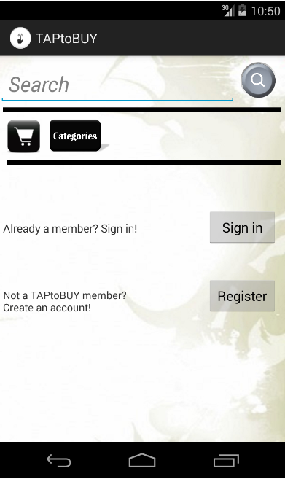

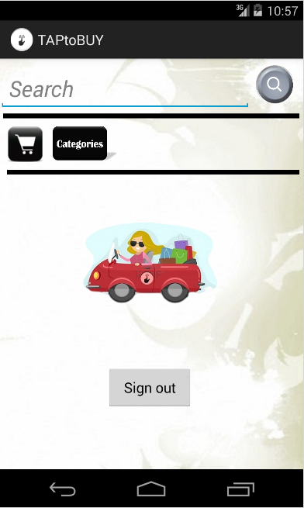 In this activity the user is able to create a new account using the “register” button, he can also Sing in, using the “sign in button”, if is a member already, search for products by writing a key word which will take him to the “Search” activity, or by categories and the user can access his cart but will be promptto sing in first (as shown below)**.**

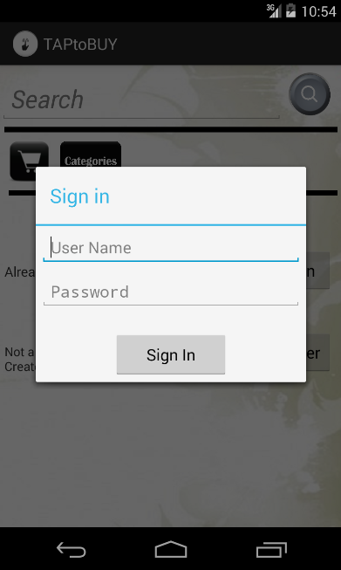

*- After the user has signed in*

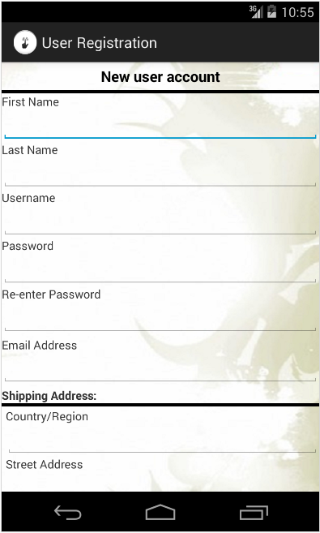**Register:**

Here is where the user is taken when it it’s the register button to create a new account, the page scrolls down until a button that says submit, so when the user is done filling the information required it can be submitted to the database.

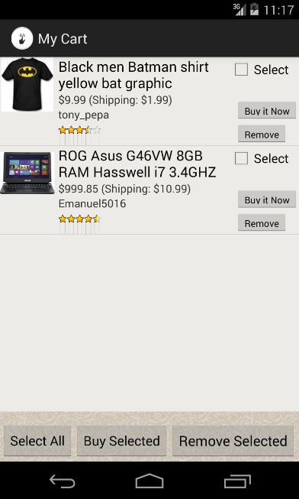

**User’s cart:**

This activity shows every item the user has put on his cart from the search, the item row shows the product title its price and shipping price, the seller username and seller rating. If the item row is tap it will take the user to the Product Details activity. In the cart he can make an order of multiple items by selecting all using the “Select All” and then **taping** the “Buy Selected” that will take the user to the “Order Checkout” activity to place and process the order. If the user no longer wants the item in his cart he can remove it by taping the remove button.

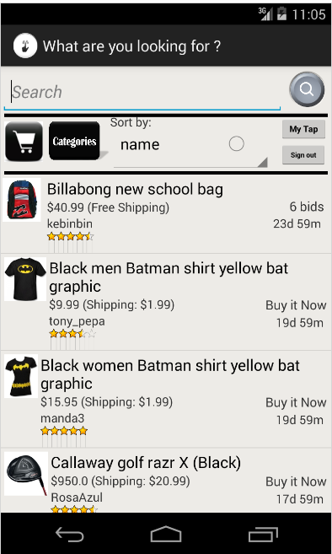

**Search & result:**

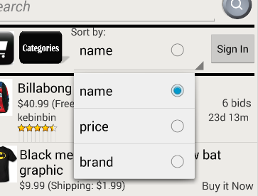Here is where the user is taken when a search is made, the user can sort the products search results by name, price or brand by taping the “Sort by” *spinner* where he can select a method as shown below:

The user can also sing in from the search if he didn’t sign at the Main TAPtoBUY activity as shown above the sign in button is available. The products row shows the product title, product price and shipping price, the seller username, seller rating and at the right side the bids amount that had been place on the product if is for auction or the buy it now text if is for sale, and below is the time remaining for that item.

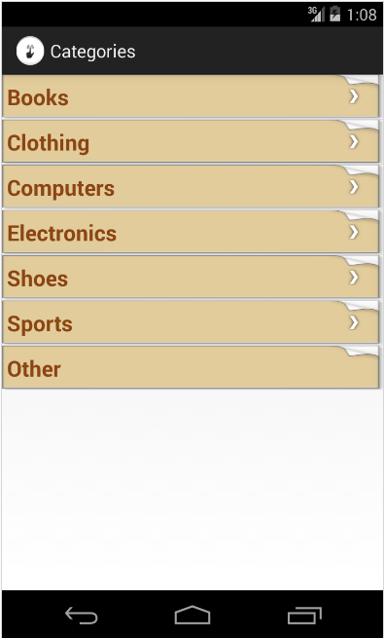

**Categories Search:**

This activity is trigger when the user taps the categories button it allows the user to search given certain categories. The user taps the categories to go into those category subcategories, if any, which is indicated by the white arrow. If there is no arrow (no more subcategories) then a search will be made within that category and the user will be taken to the Search & results activity.



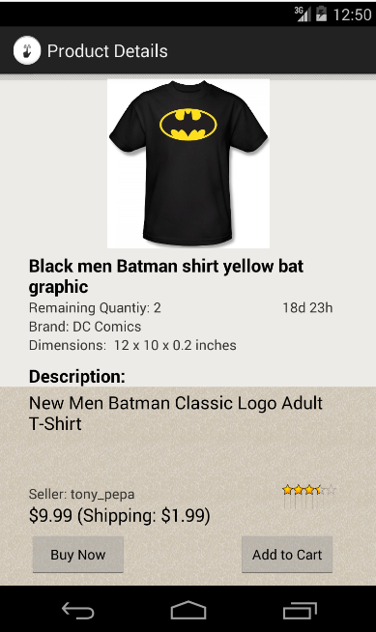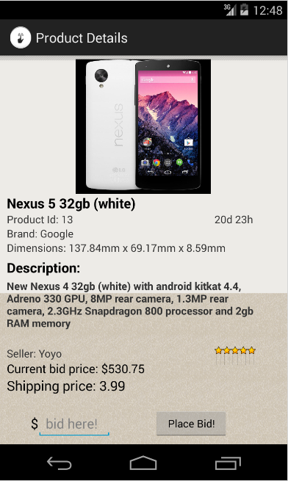

**Product Details:**

This activity is shown when the user tap on a product row that is not from My History activity, here the user can see the product and all information the seller provided about it. The user can place a bid for the product if it is for auction and if it is for sale he can add it to the Cart or tap the “Buy Now” button to go to the Checkout activity to place the order.

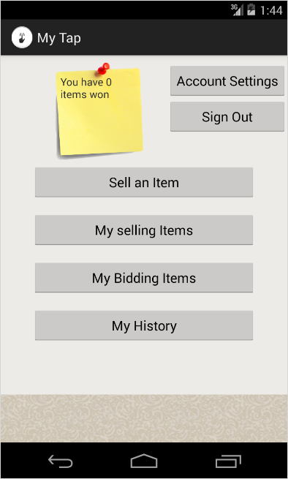

**My Tap:**

In the My Tap activity the user can access any information related to him, as seen in the picture, the notification post it will tell him if he has won an item, if the user has won an item he can go to My Bidding activity by tapping the “My Bidding Items” button and tap the item row of the won item to place the order. The “Account Settings” button will take the user to the “Account Settings activity”, the “Sign Out” to the Main TAPtoBUY activity; the “Sell an Item” button will take him to the Sell an Item activity, “My selling Items “ button takes the user to My sellings activity, and “My History” button will take him to My History activity.,



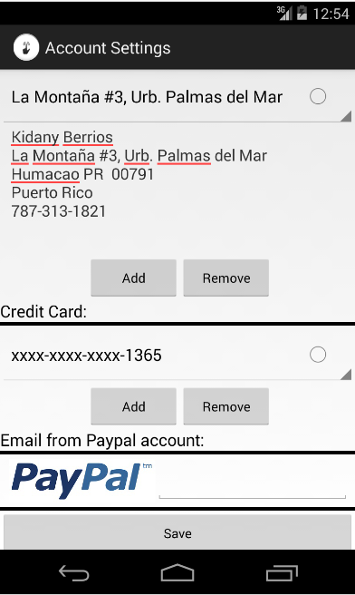

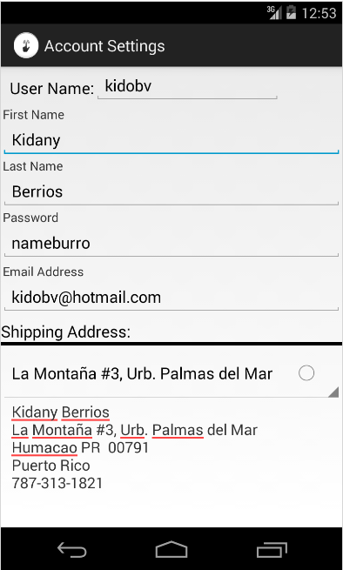

**Account Settings:**

In account settings activity the user have access to the information he provided when the account was created at the Register activity, here the user can update the account information add new shipping address and new credit cards, also if he want to sell an item it is required to fill the field of email from PayPal account in order to have a source to transfer the payment from the buyer. After he finish modifying the account information he must press the save button to save the new settings.

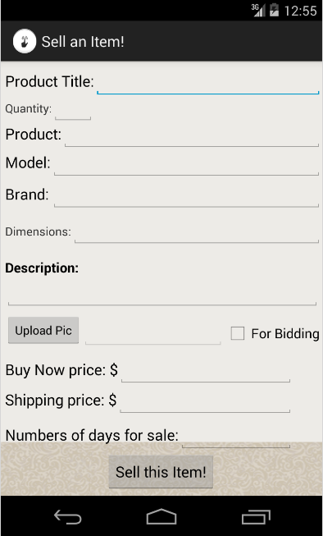

**Sell An Item:**

In this activity the user can put an item on sale or for auction, it is required that he fills every field describing the product and upload a picture; also he must had filled the email from PayPal account at account settings before submitting the product.

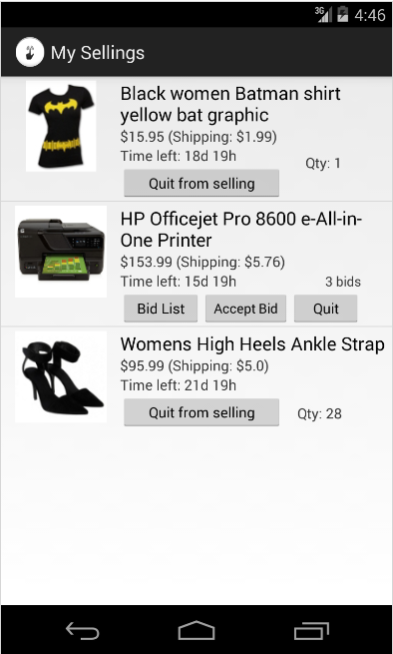

**My Selling:**

Every item the user is selling or have in auction appears here, he will be able to keep track of them since the rows show the amount of bids that had been place on an item if is for auction and the quantity left from an item on sale. The user is also able to quit the item form sale or cancel the auction. The user can also tap the item to go into Product Details activity, but obviously won’t be able to place a bid or buy it.

**My Biddings:**

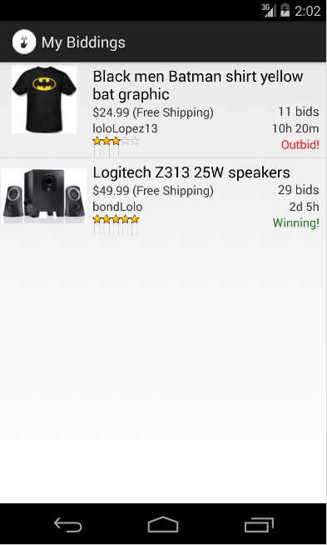

In this activity the user can keep track of the auctions he is participating on an the item row tells if he is winning an auction, losing it (out bided) or if he won the auction, which will be notify and he will be able to tap on the product to go to the Checkout activity and place the order. Otherwise while the auction hasn’t end he can tap on the item to go to the Product Detail activity.

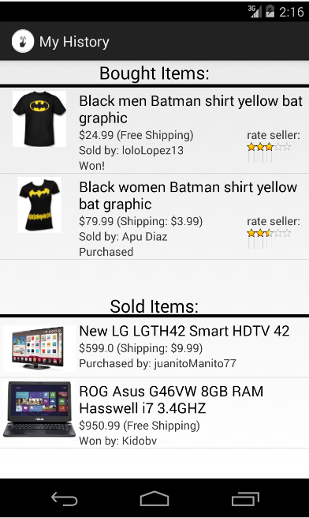

**My History:**

My History provides the user with a list of items he has bought and a list with the one he has sold. The item rows from bought items list show who was the seller of that particular item its rating, the price of the item and shipping price. The item rows from the sold items list show who was the buyer, the item paid price and the shipping price. Any of them can be tap to see the order receipt.

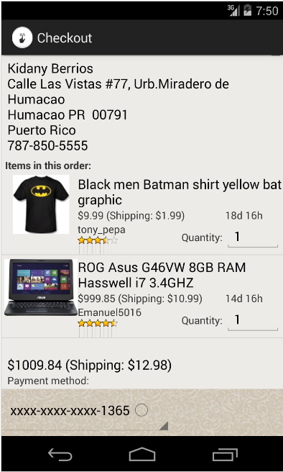

**Order Checkout:**

In this activity the user can review the order if it is accessed by the cart and the user had more than one item he can buy them all at once and the total of items will appear at the list as seen in the picture, where the user can specify the quantity of the particular item. The user can also select to which shipping address the order will be sent and which credit card to use to make the payment. After the user is done review the order he can tap the place order button which is at the end of the Order Checkout activity and the order will be place passing the receipt to My History activity.

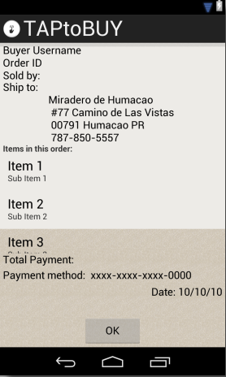

**Order Receipt:**

Here the user receives a receipt of an order made from the cart, “Buy Now” button from Product Details activity or from My Biddings activity when an item has been won by the user.

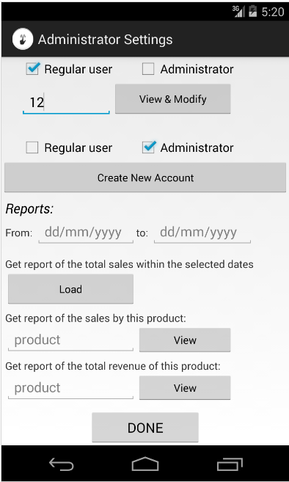

**Administrator Settings:**

This activity will only be visible by user that have administrator account it will be prompt after the administrator sign in or when the administrator tap the “myTap” button at the Search activity. Here the administrator is able to create a new regular or administrative user account also view and modify existing ones. The administrator will be able to get reports by specifying a certain date interval; reports include total sales within the selected interval, total amount of sales or revenue from a specified product.